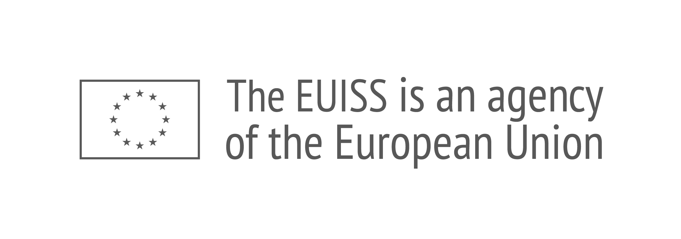
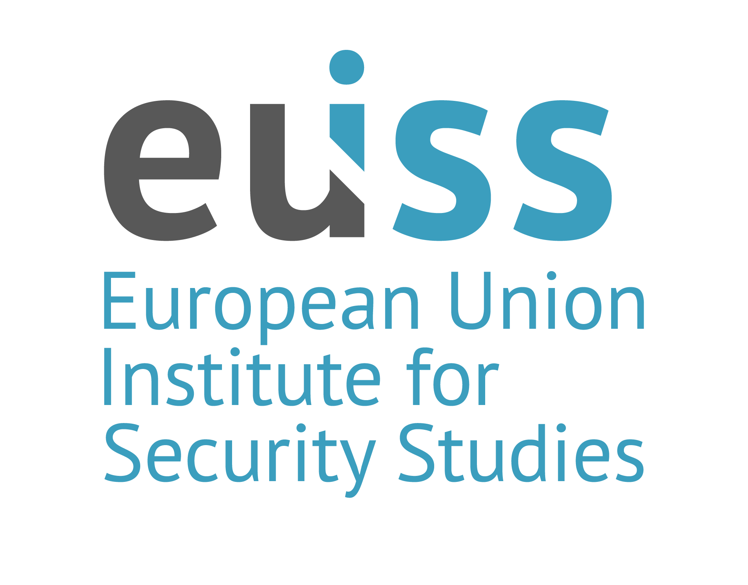
  - Spend smarter, support harder
Edited by
Ondrej Ditrych
Senior Analyst, EUISS

Empowering
Ukraine
© European Union Institute for Security Studies, 2026.
The views expressed in this publication are solely those of the author(s) and do not necessarily reflect the views of the European Union.

CATALOGUE NUMBER QN-01-26-007-EN-N
ISBN 978-92-9462-528-1
DOI 10.2815/5027129
Cover image: EUISS composite based on photography
by NATO, EDA, Envato, Unsplash
Analysis
Jul 2026
Introduction
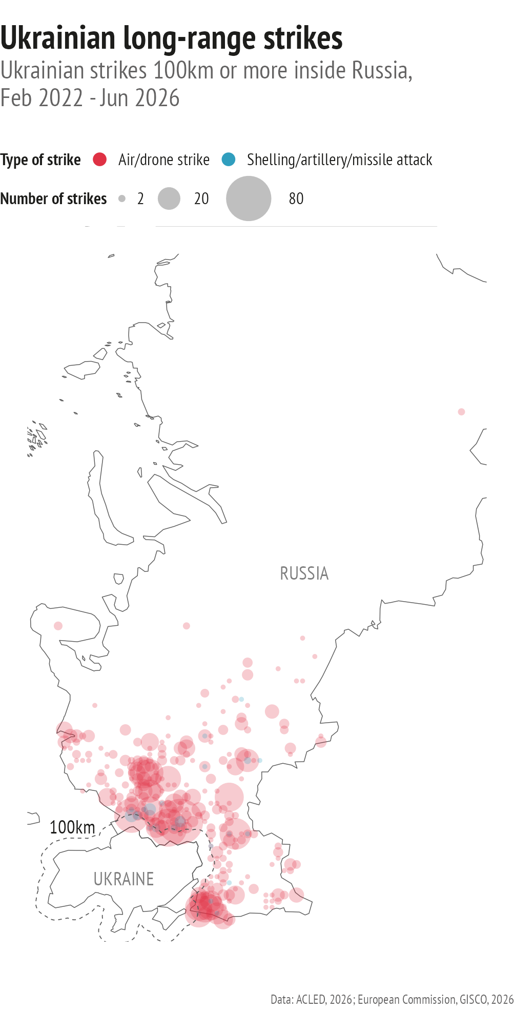
From a modest start in 2022, the number of Ukrainian strikes deep inside Russia has risen steadily. Ukrainian drones now reach targets up to 3 000 km away, including Russia’s largest oil refinery in Omsk in the heart of Siberia.
This year the number of deep strikes is set to reach a record, likely more than doubling the number of attacks recorded in 2025 (661). Domestic production of Ukrainian long-range drones capable of deep strikes increased by 53% between January and April 2026.
Meanwhile, daring operations like Spiderweb have demonstrated Ukraine’s skill in planning and conducting complex covert missions by deploying drones that successfully targeted distant Russian military airbases.
Sustained strikes on Russian energy infrastructure are also imposing rising economic costs and broadening the domestic impact of the war. Innovations like FP-1 ‘motherships’, which can launch smaller quadcopters near their targets, are increasing the effectiveness of attacks on military targets.
by
Ondrej Ditrych

For over four years, Ukraine has bravely resisted Russia’s imperialist aggression. Positive momentum has been building up. Ukraine has consolidated its defences and slowed, and in places reversed, Russia’s advances. Its defence-industrial production capacity is expanding rapidly, and its innovation ecosystem is becoming one of the country’s most valuable assets. Kyiv can rely on the EU’s support through the unprecedented €90 billion loan approved in April 2026 and has successfully mobilised international support through skilful wartime diplomacy. Even the Trump administration, known for its scepticism, now admits that Ukraine ‘has cards’. The country is also drawing closer to the EU as accession talks have finally begun. Meanwhile, Ukraine’s increasingly frequent long-range strikes deep inside Russia are steadily raising the costs of Moscow’s war of aggression.
The EU has welcomed this development as it points towards a future peace favourable to its interests. However, it should not become complacent.
Russia, while under increasing strain, can still mobilise further resources in an effort to reverse the setbacks it has suffered. Ukraine’s successes have been uneven, and Kyiv will continue to face relentless attacks against its civilian infrastructure designed to break its resolve. These will add to the immense destruction already inflicted on the country.
To defend itself and, ultimately, to rebuild, Ukraine will continue to rely on partners. Here is where this collection of proposals can offer a way forward, setting out innovative ideas to improve the ways in which the EU, foremost among those partners, can effectively empower Ukraine.
Authored by EUISS Analysts pooling their regional and thematic expertise, these contributions look beyond the immediate challenges of the war. They propose new ways in which the EU can empower Ukraine, explain why these ideas could have a transformative impact, and show how they could be translated into policy by building on existing initiatives.
The collection covers a range of subjects: from building societal resilience to deepening defence-industrial cooperation to strengthen the foundations for defending and deterring Russia; from reconstruction and recovery to Ukraine’s gradual integration into the EU; and from reinforcing international support networks for Ukraine to dismantling Russian influence networks across Africa.
In each case, the authors’ analysis of Ukraine’s current and future needs, together with an assessment of the EU’s response, paves the way for practical policy recommendations that build on existing opportunities, address systemic weaknesses and overcome key obstacles.
When they look at the approximately five million Ukrainian citizens now residing in the EU, they see them not just as people who have found refuge from war, but also as a strategic constituency to be engaged to ensure Ukraine’s future resilience and recovery. Likewise, when they look at the impressive rebirth of Ukraine’s defence industry, they see not just a sector that merits continued EU support, but also an opportunity to use joint ventures to build stronger and more enduring partnerships.
Looking ahead, the authors propose practical solutions to the challenges of rebuilding Ukraine, including likely shortages of available funding. To ensure stakeholders’ confidence and trust as well as efficient and fair use of available funds, they advocate the swift completion of a ‘single collector pipeline’ that brings together parallel funding streams within one integrated and transparent digital platform. To complement public funding, they propose new incentives for external investors, combining domestic reforms with external derisking measures to attract more private capital.
Safeguarding Ukraine’s long-term prosperity will also require governance reforms that strengthen the rule of law and improve the business environment, as well as modern infrastructure capable of powering up Ukraine’s future economic growth. This is why the authors recommend shifting the focus from ensuring the continuity of essential energy services in the face of Russia’s sustained attacks to long-term investment in a distributed energy system that could serve as a model for Europe’s future energy networks. They also caution that this infrastructure must be protected by robust safeguards to ensure that the involvement of third countries, including China, does not create undesirable dependencies or vulnerabilities to sabotage and espionage. They stress that enhanced support to Ukraine must be accompanied not only by a credible EU accession perspective, but also by accelerated integration across the functional, political and societal domains ahead of formal accession, firmly anchoring Ukraine in wider Europe while delivering tangible benefits to its population.
Finally, the authors highlight the key role the EU can play in helping Ukraine to leverage international partnerships for defence and reconstitution. Mindful of the current state of the transatlantic relationship, they argue that the EU should try to convince the Trump administration to increase pressure on a weakened Russia, and to recognise the strategic and commercial benefits of a just and lasting peace. They point in particular to the scope for expanding defence-industrial cooperation by setting up more weapons production lines in Europe, including in Ukraine. Beyond political divergences that extend well beyond public rhetoric, the authors identify common interests in Ukraine’s reconstruction and recovery. They therefore propose to create a compact, building on the G7’s Ukraine Donor Platform, to at least partially overcome collective action problems and avoid the costly consequences of a failed reconstruction effort.
They also advocate for establishing a more robust and coherent network to prevent, expose and disrupt Russia’s deceptive recruitment schemes in Africa, thereby reducing the flow of recruits to the frontline, and undermining the Kremlin’s global influence.
The ambition of this collection is to inspire new policies and encourage a more innovative way of thinking about how the EU can empower Ukraine that is firmly grounded in an understanding of where the EU’s key strategic interests lie.
It is mindful of the substantial support that the EU offers to Ukraine, but also of the challenges ahead.
To date, the EU and its Member States have provided €211.3 billion overall in support (including €3.8 billion windfall revenues from immobilised Russian assets).
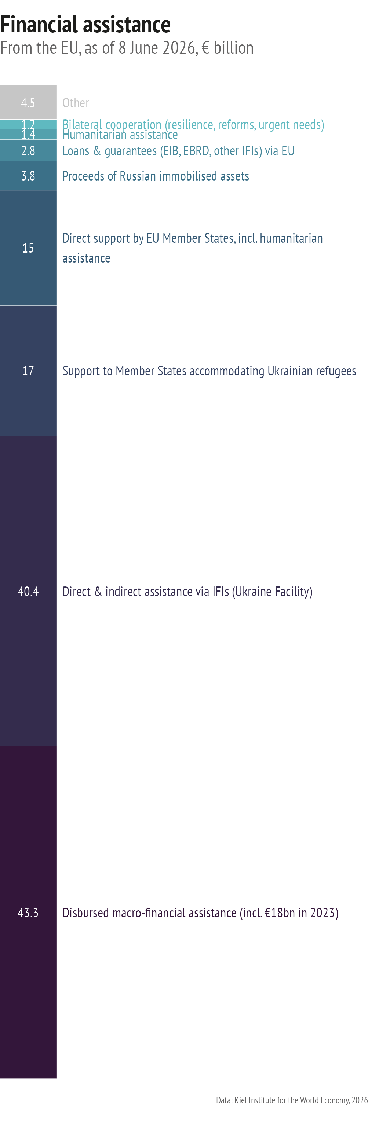
The amount of the EU’s support exceeds that of any other international donor. The US comes a distant second, having provided an estimated €120 billion worth of support, according to the Kiel Institute’s Ukraine Support Tracker.
Since the second Trump administration took office, US direct support to Ukraine has largely petered out.
However, the EU has stepped up its assistance to offset this decline, increasing military aid by 67% and non-military aid by 59% above the previous three-year average, as recorded by the Kiel Institute.
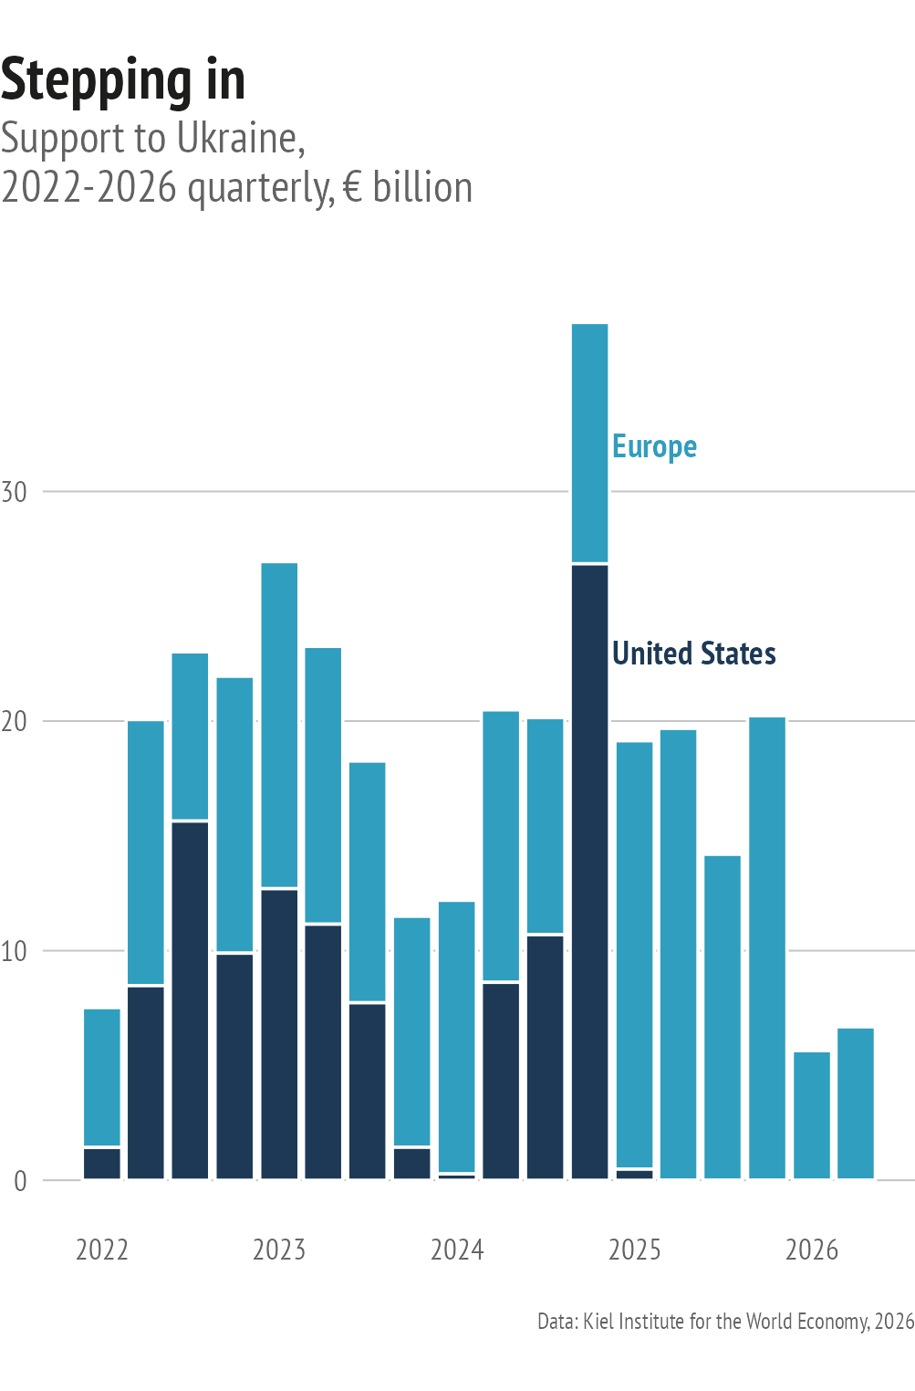
In addition to increasing financial aid, the EU has supported the training of Ukraine’s armed forces and security sector reform through two CSDP missions – EUMAM (which, at the time of writing, has trained over 93 000 Ukrainian troops) and EUAM. Meanwhile, extending defence-industrial cooperation and Ukraine’s integration into initiatives such as Security Action for Europe (SAFE) and the European Defence Industry Programme (EDIP) allows Ukraine to pool financing, production capacity and innovation with its European partners to meet shared defence needs more effectively.
The EU is also looking to the future. It has earmarked €100 billion for further support to Ukraine under the next Multiannual Financial Framework (MFF). However, Europe’s fiscal space is under pressure as Member States increase spending on their own defence to deter the mounting threat from Russia, while the US recalibrates its security and defence priorities. The EU is therefore keeping open the option of using immobilised Russian assets in the future to repay the support loan and finance a new reparations loan for Ukraine. Assets immobilised in Member States amount to €209.2 billion, or 72.3% of the global total.
The reality is that Ukraine’s reconstruction and recovery needs will be several times greater than the amount the EU has earmarked for 2028-2034. Member States and other donors can still mobilise additional resources, but they are being stretched thin. Unlocking private capital can provide an important additional source of funding.
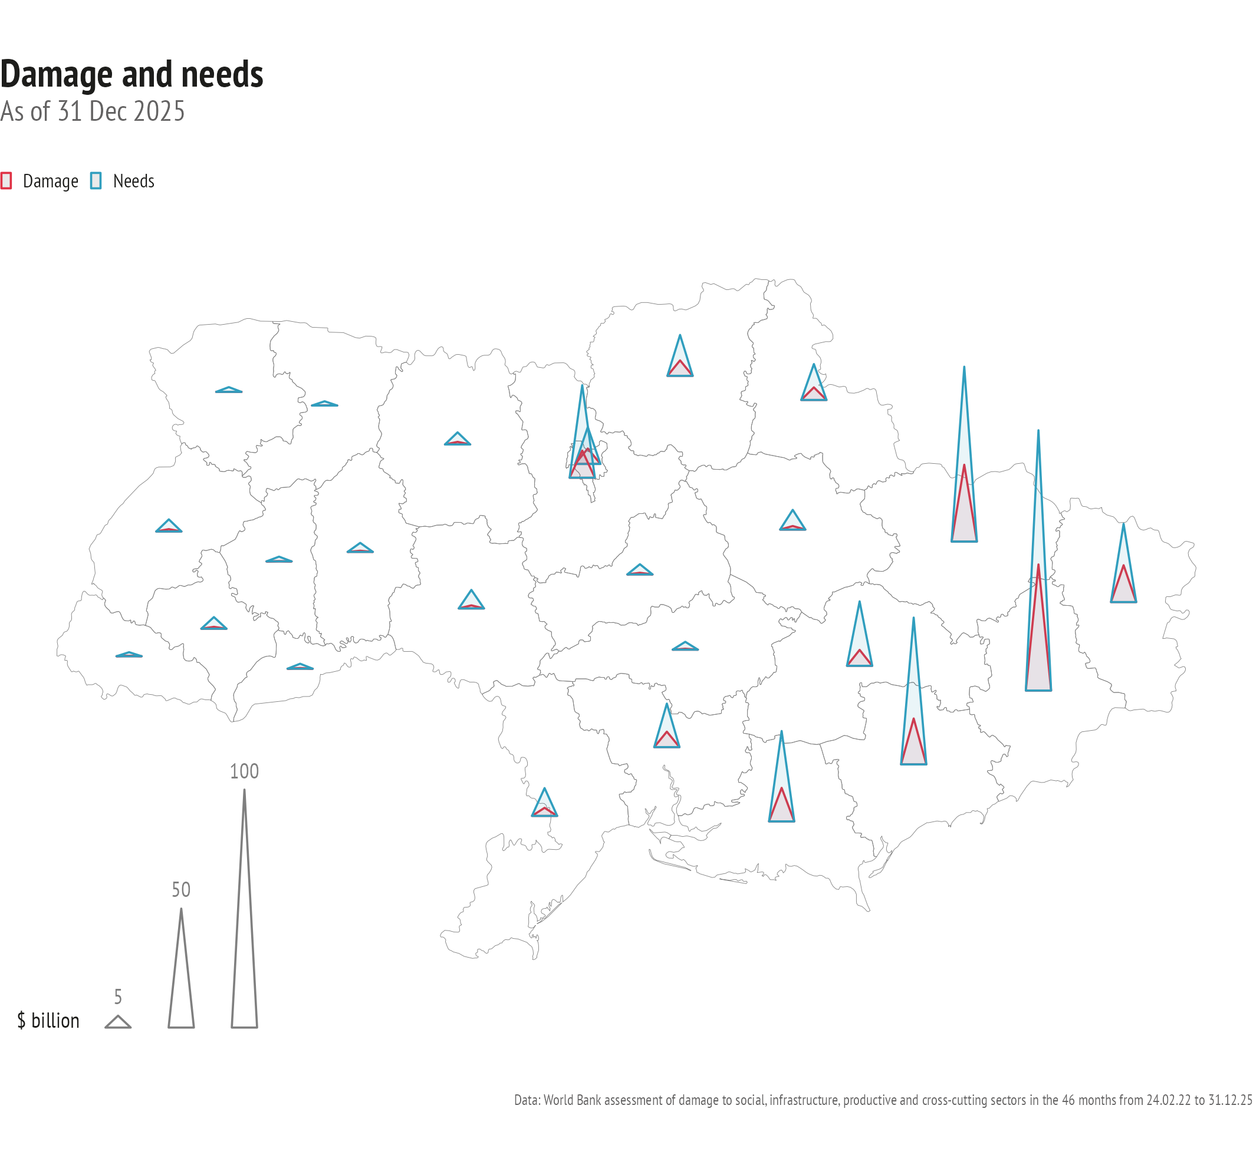
But still, EU support will need to continue over a sustained period after a ceasefire is reached and until the now devasted Ukrainian economy is capable of generating sufficient revenue – and comes to resemble the government’s vision of a liberal ‘Economy of the Future’ with sustained growth, foreign direct investment (FDI) exceeding prewar levels and conditions conducive to the eventual return of at least three million Ukrainians from abroad to meet the country’s labour needs. Russia’s war has caused terrible human suffering and vast economic damage. The most recent Rapid Damage and Needs Assessment (RDNA5), undertaken by the European Commission together with the World Bank, the Ukrainian government and the UN and published in February 2026, estimates the country’s reconstruction and recovery needs over the next decade at €515.3 billion, or three times Ukraine’s nominal GDP. Of this amount, up to 40% (but no more than that) could be met by the private sector provided necessary governance reforms take place. Much of the damage is due to Russia’s deliberate targeting of Ukrainian civilian infrastructure, which has steadily intensified over time.
The damage has been distributed unevenly across Ukraine’s regions, including the territories under illegal Russian occupation.
Donetska oblast accounts for about one quarter of the overall damage, while Kharkivska and Zaporizka oblasts together account for another quarter.
As a result, reconstruction and recovery needs vary significantly across the country. The most severely hit frontline regions risk failing to attract sufficient funding.
Meanwhile, the likelihood of a ceasefire agreement being reached in 2026 is slim. Russia may seek to exploit diplomatic negotiations as a way of achieving its war objectives – in other words, as a continuation of war by other means. However, it can no longer place hopes in the Trump administration as it once did. The conditions each side considers acceptable for a ceasefire continue to differ dramatically, while neither side has the military capacity to achieve a decisive breakthrough on the battlefield. Both Ukraine and Russia now have the capacity to inflict significant damage deep behind enemy lines, but both appear willing to bear the costs of a prolonged war. Ukraine’s ability to strike military infrastructure close to the frontline, as well as logistics hubs and oil refineries deep inside Russia, has increased sharply. This is complicating the delivery of Russian supplies to the front, constraining Russia’s petroleum exports, and creating fuel shortages during the peak summer demand season that extend beyond Moscow to nearly all regions in the country. Illegally occupied Crimea features prominently among the targeted territories. However, Russia maintains missile superiority, while Ukraine struggles to field sufficient air defences.
The Kremlin may still believe that it can take the whole of Donbas and use it as a springboard for renewed pressure further inland. But neither side is likely to make significant advances on the ground. Both continue to believe, however, that they can improve their position through deep strikes: Ukraine by intensifying pressure on Russia’s fuel supply, and Russia by once again targeting Ukraine’s energy and heating infrastructure come winter.
This situation is not conducive to a ceasefire in the near future. But neither is it a stalemate. Ukraine is now in a much stronger relative position vis-à-vis Russia than at the beginning of 2026, while the latter’s vulnerabilities are becoming increasingly evident. Russia’s economy is now contracting for the first time since 2023.
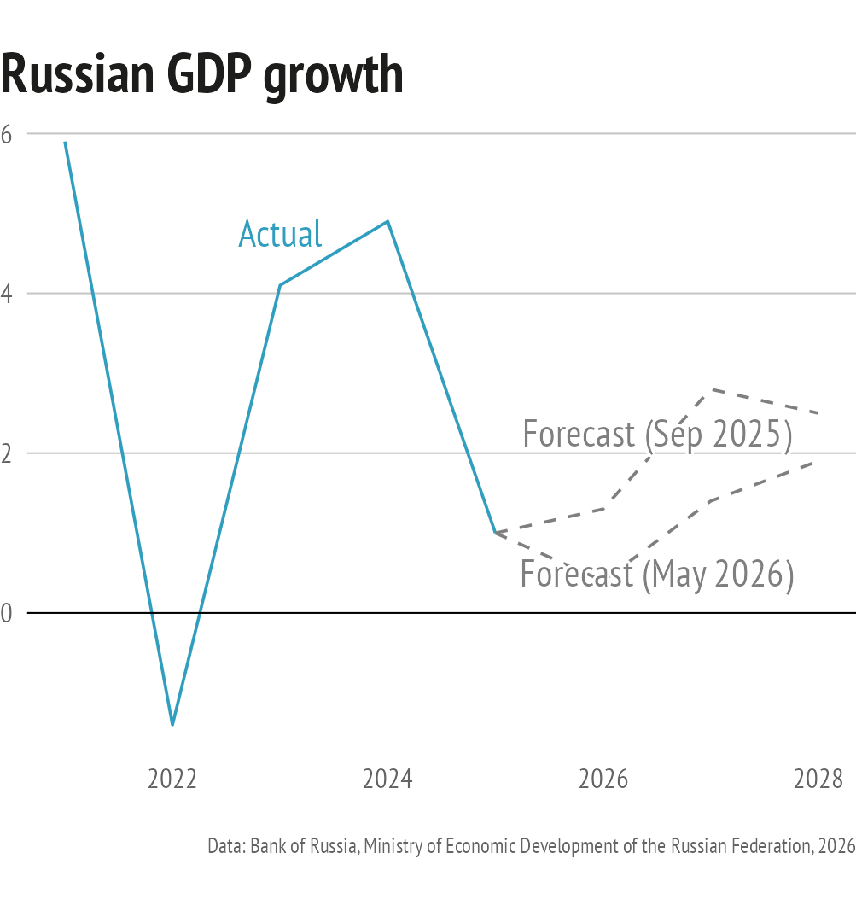
The windfall from the Hormuz crisis offered Moscow a welcome lifeline but did little more than temporarily plug the holes in an increasingly leaky ship. Signs of war fatigue are becoming more and more visible in Russian society, while even within the elite there are occasional, if fleeting, expressions of discontent over a war that has claimed the lives of 450 000 Russian soldiers.
This is the moment to increase pressure on the Kremlin and work to unpower it. Defeating Putin’s imperialist project will require a sustained long-term effort, with empowering Ukraine remaining central to that strategy.
Steadfast support by the EU, Ukraine’s key partner, will be essential both to help Ukraine secure a favourable peace agreement, and to manage the aftermath. The post-war period is likely to be characterised by economic malaise, a persistent security deficit and a difficult transition from martial law to a new political ‘normal’. The Kremlin will spare no effort to foment internal instability and drive a wedge between Ukraine and the EU.
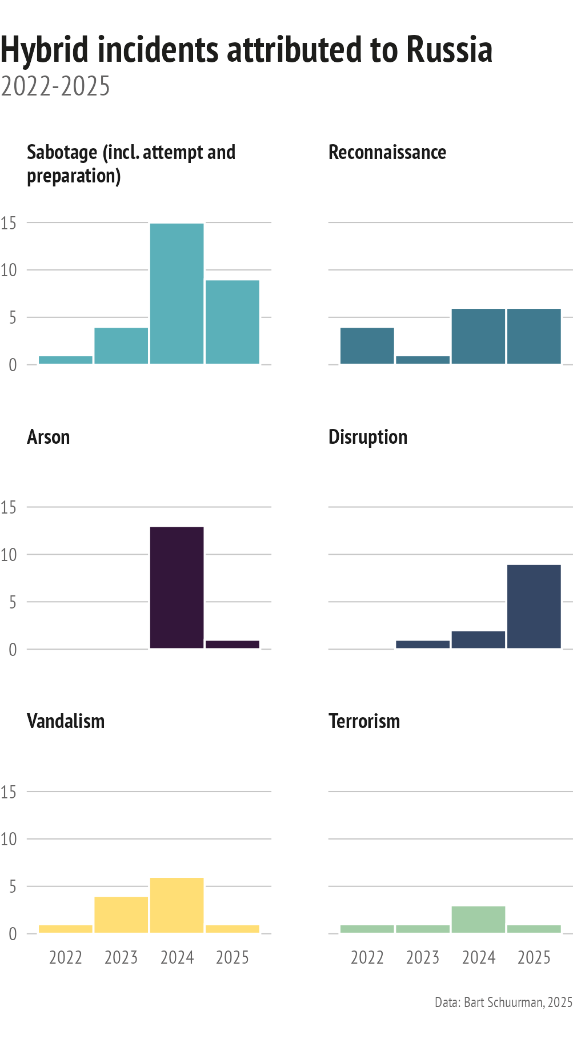
Russia-engineered foreign information manipulation and interference (FIMI) campaigns will, as they already do at present, persistently and opportunistically exploit insecurities in both Ukraine and the EU, amplify perceptions of incompatible values, and seek to turn citizens against ‘elites’ portrayed as betraying their real interests. The Kremlin will seek both to undermine the enlargement process, and to use that process to undermine the EU and Ukraine.
To make sure it does not succeed, and to safeguard the accession process that anchors the vision of a free and democratic Ukraine in a united Europe, will require robust resilience on both sides.
Ensuring that an empowered Ukraine is on its side, and becomes a Member State down the road, is one of the EU’s core strategic interests in the face of Russia’s efforts to rebuild its empire. Externalising threats that by default are shared by the community of European states is not a realistic option. Empowering Ukraine is a major undertaking. It requires political resolve, a clear understanding of the challenges ahead and a readiness to confront them head-on. Above all it requires forward-thinking about how this objective can be pursued more effectively and, where possible, at lower cost.

Defence Integration Booster
Better use of joint ventures can accelerate Ukraine’s integration into the EU defence industrial base
by
Ondrej Ditrych and Luigi Scazzieri

The unique qualities of Ukraine’s defence industry are central to the success of its war effort. The industry will be key to maintain deterrence against Russia even once a sustained ceasefire is in place. Beyond security, it is also one of the most promising sectors for rebuilding Ukraine’s peacetime economy.
The industry has transformed massively since 2022: it has undergone exponential growth while becoming a driver of innovation, in particular in uncrewed systems. However, it remains vulnerable to Russian attacks and faces significant financing constraints. Moreover, a sustained ceasefire would create uncertainty over the future level of demand, which could lead to a contraction of the sector unless Ukraine develops export opportunities.
The EU is already doing much to foster Ukraine’s integration into Europe’s defence base, notably by giving Ukraine access to its defence funding instruments. In parallel, a growing number of partnerships are emerging at the industrial level between Ukrainian and EU firms and governments. The EU should give further momentum to this process by expanding and revamping its support measures. This contribution focuses on one specific dimension of that agenda: how EU-based joint ventures between European and Ukrainian firms can give Ukraine greater production depth, and improve its access to technology, capital and European procurement markets.
Impetus
Ukraine’s defence industry, once a pillar of Ukraine’s Soviet-era economy before falling into decades of decline, has undergone a remarkable revival since 2022. It is now one of the country’s most important wartime assets and could become a key driver of its peacetime economy. However, it faces two key vulnerabilities. First, production facilities in Ukraine remain exposed to Russian attacks. Second, a sustained ceasefire could lead to a fall in domestic procurement, leaving firms without sufficient demand and forcing them to downsize. This would result in a loss of production capacity and make it more difficult to maintain the innovative edge that is Ukraine’s unique strength. The economic costs would be considerable. Ukraine is on course to generate more income from arms exports in 2026 than it did prior to Russia’s full-scale invasion, and its overall production capacity could expand to USD 50 billion by 2028. A contraction of the industry could therefore undercut Ukraine’s economic recovery. In addition, it could also undermine its long-term ability to deter future Russian aggression.
This makes integration into the European Defence Technological and Industrial Base (EDTIB) strategically important to empower Ukraine. European production capacity can provide added depth in the short term. Enhanced access to European procurement systems could unlock a major new source of funding and create sustained demand even in the event of a ceasefire. Moreover, partnering with European companies can provide Ukrainian firms with specific technology and know-how. However, the form of cooperation matters. Relocating a part of Ukrainian production to Europe may improve resilience, but it does not automatically provide access to European funding, technology, certification or procurement markets. Beyond the industrial dimension, deeper defence industrial cooperation and integration will further facilitate the inclusion of Ukraine in the European security community by fostering close collaboration in a sector that has traditionally remained highly nationalised.
Idea
To sustain the impressive development of its defence industry and maintain its competitive edge, Ukraine needs access to four things that Europe can provide: capital, production depth, access to key technologies and assured future demand. Accelerating Ukraine’s EDTIB integration should therefore focus on several parallel lines of action: facilitating access to funding, encouraging European firms to work in Ukraine, supporting Ukrainian firms operating in Europe, and fostering genuine partnerships between the two sides.
The EU should pursue integration along all these dimensions. Joint ventures based in Europe, in which both European and Ukrainian companies contribute intellectual property or production know-how, can play a particularly important role. They can deepen industrial partnerships while helping overcome key obstacles to cooperation. First, they offer a way around the reluctance of many European companies to establish production in Ukraine due to concerns about tech sharing, intellectual property and public procurement, as well as the risk posed to production facilities by Russian attacks. Producing more Ukrainian or Ukrainian-derived systems in Europe would help secure production, allow firms to draw on European industrial capacity, and attract greater European investment in Ukraine’s defence industry.
Second, despite its remarkable innovation, Ukraine still needs access to European technologies, components and systems-integration expertise in more complex capability areas such as air defence and deep strike. Joint ventures can bridge this gap by reducing the risks that often make European companies reluctant to share technology, particularly with partners based in Ukraine.
Third, EU-based joint ventures can help Ukrainian companies gain access to European and NATO procurement markets, which are essential for their long-term survival. European governments are increasing defence spending and becoming more open to broadening procurement to new players. However, Ukrainian products are not automatically easy for European governments to procure, even if a company wants to sell and has government backing. Joint ventures with European firms used to navigating NATO-standard procurement systems can help Ukrainian companies secure contracts and a funding stream. The prospect of export earnings may also be a powerful inducement for Ukrainian firms to persuade the government to grant export licences under the mechanism introduced in June to attract greater international investment.
Instruments
European firms are increasingly setting up operations in Ukraine, for example the successful Rheinmetall Ukrainian Defence Industry LLC. In parallel, Ukrainian companies like Firepoint are setting up production in Europe. Several EU governments, such as Denmark and the Netherlands, are actively encouraging partnerships with Ukrainian companies and production in Europe. Joint ventures are already an important element of this cooperation architecture. For example, Auterion Airlogix, which combines Ukrainian and German expertise in artificial intelligence (AI), illustrates how such ventures can link Ukrainian firms with partners that bring capital, facilitate certification and systems integration and provide access to procurement opportunities.
To encourage the wider use of joint ventures and make them more efficient, the EU could adapt its funding instruments to incentivise their creation. Currently, an EU-headquartered joint venture that combines European and Ukrainian technology to facilitate technology sharing, manage export controls and access the EU market is classified simply as a ‘European’ company and receives no particular support from the EU. Future EU defence-industrial funding instruments could give greater weight to projects in which Ukrainian firms contribute core intellectual property or production know-how through European-incorporated joint ventures.
Beyond adjusting its instruments, the EU could help assemble funding packages for joint ventures. Past examples, including Denmark’s €67 million envelope, show that establishing production facilities requires substantial public funding, as well as government backing to secure the necessary permits. The EU could help coordinate packages combining host-state funding, EU financing, European Investment Bank (EIB) financing for eligible dual-use elements, and private capital. Moreover, the next Multiannual Financial Framework (MFF) could also include a dedicated EU defence-industrial budget line to encourage the creation of joint ventures.
Public support should also include clear demand signals. To help joint ventures scale up production, Member States should consider framework contracts and advance purchase commitments that would give firms the certainty needed to increase production capacity and attract private capital. To facilitate testing and certification, Member States should provide Ukrainian firms and Ukrainian-European partnerships, including EU-based joint ventures, with access to testing facilities.

The diaspora connection
Engaging Ukrainians in Europe for resilience and security
by
Nad'a Kovalčíková

Once a sustained ceasefire is in place, Ukraine’s first post-war elections will be a defining test of the country’s democratic resilience. The circumstances will be exceptional. Yet seen from this perspective, the approximately five million Ukrainian citizens now residing across numerous EU Member States are more than displaced people: they are also a strategic democratic constituency whose resilience and political engagement will help shape both their country’s recovery and the future of European security. To ensure that Europe’s military, financial and political investment in Ukraine delivers lasting results, Ukraine must emerge from Russia’s war of aggression not only as a stable state, but also as a reliable democratic partner. The EU should therefore help safeguard the integrity of out-of-country voting while harnessing the wartime experience and civic engagement of Ukrainians living in Europe to strengthen resilience against Russian interference.
Impetus
Creating favourable conditions for Ukrainians living in the EU and for those who choose to return home requires early preparation and sustained engagement to build trust, develop skills and capacities, and strengthen civic networks across Europe, thereby supporting Ukraine’s postwar reconstruction and recovery. In parallel, leveraging Ukrainians’ wartime experience can help EU Member States to enhance whole-of-society resilience and civil-military preparedness through joint resilience-building activities.
Existing initiatives led by organisations such as International IDEA or the International Foundation for Electoral Systems (IFES) focus on the technical and regulatory challenges of out-of-country voting to strengthen democratic legitimacy, social cohesion and long-term stability in Ukraine. Complementing these efforts, non-governmental and non-partisan organisations like OPORA also engage Ukrainians across borders in activities that reinforce democratic resilience. These include election monitoring, integrating security mechanisms into democratic governance, countering disinformation, documenting war crimes and international advocacy.
Beyond continued funding, the EU could build on these efforts by institutionalising and expanding support for initiatives that foster the resilience of Ukrainians as a whole, both at home and abroad, while engaging them to address a wider set of democratic and societal challenges shared with EU citizens. Stronger EU-Ukraine civic resilience networks would help ensure that this engagement endures beyond a ceasefire. Integrated measures will also reduce the risk of widespread disenfranchisement and reinforce the legitimacy and integrity of future elections, which will almost certainly be a target for Russian interference.
For the EU, supporting such efforts is not only an act of solidarity. It is also an investment in safeguarding Ukraine's – and by, extension, Europe’s – democratic, secure and prosperous future.
Idea
One way to strengthen democratic resilience is to support the integrity of out-of-country voting by Ukrainian diaspora communities, treating it as a strategic investment rather than a short-term project or a purely technical electoral exercise. At the same time, investing in broader, long-term transnational resilience programmes would help sustain democratic connections long after temporary protection arrangements expire. Such programmes would also strengthen European security by increasing capacities against foreign interference.
Before Russia’s war of aggression against Ukraine, out-of-country voting relied largely on embassies and consulates. The model is no longer fit for purpose. Millions of Ukrainians are now dispersed across dozens of Member States, often with outdated voter registration records, and subject to different legal and administrative frameworks in their host countries. A limited number of consular officials are responsible for serving communities often numbering in the hundreds of thousands. In many cases, diaspora organisations have stepped in to fill this gap, acting as trusted intermediaries between the Ukrainian authorities and citizens.
Out-of-country voting in future elections will not merely be a technical electoral exercise. It will likely be one of the largest cross-border democratic governance operations ever conducted, requiring coordination across multiple EU Member States and close cooperation with the Ukrainian authorities to enable large-scale electoral participation. Success will depend not only on voter engagement but also on structured dialogue, agreements (such as Memoranda of Understanding) and operational cooperation between host-country authorities, the Ukrainian authorities, domestic civil society, Ukrainian diaspora organisations and citizens in Ukraine. Fruitful cooperation must begin well ahead of the electoral process. It requires early and effective communication and sustained financial and operational investment. This should include expanding polling facilities beyond embassies and consulates to facilitate in-person voting, coordinating voter registration, putting in place the necessary security and legal arrangements and developing systematic channels of communication with Ukrainian citizens living abroad.
Secondly, building societal and electoral resilience takes time and requires early institutional preparedness. It should include joint training and simulation exercises involving election officials, civilian and military personnel, and Ukrainian citizens both with and without wartime experience as part of a broader effort to strengthen integrated, transnational resilience. Such an approach would also improve the capacity to anticipate and manage potential disruptions. Strengthening the resilience of Ukrainians living abroad against Russia’s interference activities will be critical before, during and in the aftermath of Ukraine’s first post-war elections. Moscow has repeatedly demonstrated its willingness to exploit elections and societal divisions. Future Ukrainian elections will likely become a prime target of hybrid Russian attacks, in particular through information operations. Experience across Europe suggests that citizens’ resilience to information manipulation is strengthened not only through fact-checking, monitoring and media literacy initiatives, but also through deeper social cohesion. Displaced populations are often exposed to fragmented information environments, making them particularly vulnerable to disinformation. This is especially the case when diaspora communities are not well-integrated into their host societies or organised among themselves.
Instruments
Ukrainian institutions, including the Central Election Commission of Ukraine, have been engaging with the host countries of Ukrainian diaspora communities to develop detailed technical recommendations on future out-of-country voting arrangements. To strengthen the integrity of upcoming electoral processes, the EU could complement these efforts by providing sustained, forward-looking support to democratic actors working with Ukrainians abroad. It should start by identifying established organisations that represent and mobilise Ukrainian diaspora communities across the EU as key institutional partners. Their organisational structure and levels of engagement vary considerably across Member States, in part due to different waves of immigration before and after Russia’s full-scale invasion, as well as differences in local integration or social conditions. Consequently, the EU must engage with a diverse network of actors, ranging from established and well-coordinated Ukrainian associations, for example in Poland, Spain and Sweden, to more fragmented diaspora groups, e.g. in neighbouring Moldova.
The EU can also build on recent proposals developed by democracy-focused organisations, some of which featured also in a non-paper circulated by Sweden in the Council of the EU in March 2026, and which have been endorsed by seven other EU Member States. In particular, it should leverage the 2028-2034 Global Europe instrument under the next Multiannual Financial Framework (MFF) to scale up support for democratic resilience efforts as part of the EU’s external action. This could in particular benefit Ukrainian civil society organisations working with counterparts across the EU to mobilise and engage Ukrainian democratic constituencies abroad. Although the next MFF may take effect only after Ukraine’s first post-war elections, strengthened investment in democracy with targeted funding and support to organisations cooperating across Ukraine and the EU will generate significant returns for security and economic development by fostering sustainable civic partnerships across borders.
Particular attention should be paid to social media platforms (especially Telegram, YouTube, Instagram and Facebook) and messaging applications. Ukrainian communities across Europe rely on them as their main sources of information about events in Ukraine, but threat actors also exploit them to manipulate information. Other online media and informal social networks also play an important role in shaping information consumption within Ukrainian communities.
To help counter such interference during elections, the EU should further encourage Ukraine to swiftly align with its regulatory framework, including the Digital Services Act, the Regulation on the transparency and targeting of political advertising, and the Digital Markets Act. Over the longer term, the EU should sustain its engagement with the targeted communities through both election-related and resilience-building exercises. These should draw on Ukrainians’ wartime experience (for example, activities organised by the European Security and Defence College) and complement voter education, media and digital literacy initiatives, as well as structured community dialogue with trusted diaspora organisations in host countries and neighbouring states. Such measures would strengthen electoral and broader societal resilience while helping to reduce disparities in integration and democratic participation.
The European Centre for Democratic Resilience already provides a platform for targeted partnership initiatives led by Member States. It could also foster stronger links with the Ukrainian diaspora to engage communities across Europe in resilience and security efforts, particularly around elections, when democratic legitimacy and electoral integrity are most at risk.

Integration accelerator
How to anchor Ukraine in the EU before membership
by
Bojana Zorić

The EU must adopt a more realistic approach to Ukraine's integration. Suggesting that membership is just around the corner risks undermining the EU’s credibility and weakening its leverage over the reforms that accession requires. The opening of accession negotiations on the first two clusters, together with the recent Franco-German non-paper on EU enlargement, have given new impetus to Ukraine's European path. Nevertheless, accession remains a long-term process constrained not only by the pace of reforms in Ukraine, but also by political realities within the Union itself.
A realistic approach means shifting the focus from politically driven accession timelines towards concrete integration milestones that deliver visible benefits. This should become the cornerstone of the EU's strategy towards Kyiv: functional integration is not an alternative to membership, but a way of progressively and irreversibly anchoring Ukraine in the European security and economic space while preparing the ground for full EU accession.
Impetus
This is no longer merely a question of enlargement, but a European security issue. Ukraine already possesses one of the continent’s most capable armies, significant battlefield experience and a rapidly developing defence-industrial sector. Anchoring Ukraine more deeply in European structures would strengthen both Ukraine’s resilience and Europe’s long-term security architecture. This makes the credibility of the EU's approach towards Ukraine strategically important.
Anything short of full EU membership in the near term is likely to disappoint Ukrainians. If expectations in Ukraine are not met, disillusionment could weaken the country's pro-European orientation and create openings for Russian hybrid warfare tactics. While Ukraine is unlikely to reverse its European course, unmet expectations could fuel reform fatigue and reinforce narratives that the EU's promises are ultimately unattainable. This would erode the EU's ability to drive reforms through the prospect of integration and eventual membership. Functional integration should therefore be treated not simply as an economic instrument, but as a geopolitical tool that reduces Russian leverage by building irreversible interdependence between Ukraine and the EU while strengthening Europe's long-term security architecture.
Idea
The EU should complement the accession process through an integration accelerator centred on deeper functional integration. A precedent already exists. In 1989, when full accession was not yet politically feasible, Commission President Jacques Delors proposed anchoring European Free Trade Association (EFTA) countries in the Single Market without immediate accession. This model, later realised through the European Economic Area (EEA), enabled deep economic integration and regulatory convergence before membership became politically possible.
A similar logic should guide the EU's approach to Ukraine today. Gradual integration is the most politically sustainable way to reconcile support for Ukraine across the Member States with the integrity of the enlargement process. The strategy should combine three mutually reinforcing dimensions: functional integration, political integration and societal integration.
Firstly, functional integration should focus on areas where practical gains are already achievable, including electricity market coupling, digital integration, industrial standards, trade and defence-industrial cooperation. Full coupling of Ukraine’s electricity market with the EU by 2027 would support reconstruction, attract investment, strengthen energy security and resilience, and integrate Ukraine more deeply into the European energy market. Defence-industrial cooperation offers another example, as argued by Ondřej Ditrych and Luigi Scazzieri in the chapter 'Defence Integration Booster'.
Secondly, if Ukraine is expected to align with EU rules and absorb the costs of partial access to the Single Market, it should also be granted political recognition and inclusion. Ukrainian ministers could therefore participate without full voting rights in selected Council discussions related to energy, transport, digital policy and defence-industrial cooperation, while Ukraine should be progressively included in relevant EU platforms and agencies. This would help ensure that integration is experienced not only as conditionality, but also as political belonging.
Thirdly, integration must be visible to citizens. Ukraine’s participation in the ‘Roam Like at Home’ policy from January 2026 demonstrates how European integration can deliver tangible improvements in everyday life. Similar efforts in mobility, education and people-to-people exchanges would help ensure that the benefits of integration are experienced not only through institutional cooperation, but also in citizens’ daily lives. These initiatives should be accompanied by coherent strategic messaging from the EU and Ukraine that clearly explains what each integration milestone delivers and how it advances Ukraine's path to EU membership.
Instruments
The next Multiannual Financial Framework (MFF) offers an opportunity to align the EU's financial support more closely with Ukraine's integration trajectory. While the proposed Ukraine Reserve, channelled through the pre-accession Global Europe instrument, will make available up to €100 billion for 2028–2034, this falls well short of Ukraine's estimated reconstruction needs of more than €520 billion over the coming decade. Future EU support must do more than finance recovery: it should also accelerate Ukraine's integration into the Union. To this end, the Ukraine Reserve should link reconstruction funding, accession-related reforms and sectoral integration within a single strategic framework. Financial support should increasingly be tied to concrete integration milestones in areas such as energy, digital policy, transport and defence-industrial cooperation, while reforms should also improve Ukraine's business and investment climate to help mobilise much-needed private investment.
At the same time, the EU must recognise that deeper market access will entail adjustment costs. Certain Ukrainian sectors – such as steel, transport and energy – could face significant competitive and regulatory pressures from closer participation in the Single Market. Market opening should be accompanied by transitional arrangements, safeguard mechanisms and targeted financial support. Continued access should remain conditional on sustained reforms, democratic alignment and improvements in the rule of law, allowing the EU to maintain leverage against backsliding.

A ‘collector pipeline’ for recovery flows
How to make the most of the reconstruction funding
by
Ondrej Ditrych

Ukraine has become the single largest recipient of development assistance (ODA) in the world since 2022, in addition to military aid received from partners. Despite the constraints of wartime, Kyiv has significantly improved the way it manages and allocates this assistance notably through the Public Investment Management (PIM) framework introduced in 2025. However, ensuring transparent governance, effective coordination and equitable allocation of aid and investment remains a major challenge. Further legislative reforms, stronger institutions, better process management and increased human resources are needed to replace the current ad hoc approach to allocating funds, including within the Strategic Investment Council established in 2024. This approach risks undermining stakeholders’ confidence and trust. To secure sufficient funding upstream and improve the efficiency and fairness of recovery efforts downstream, Ukraine should create a single ‘collector pipeline’ for reconstruction and recovery funding, bringing together parallel donor funding streams within one integrated digital platform. This would provide the government with a comprehensive overview to improve planning, coordinate investment decisions and strengthen public accountability. As a major donor and investment stakeholder, the EU has both the leverage and the technical expertise to support this project.
Impetus
The scale of destruction wrought by Russia’s war of aggression has created immense recovery and reconstruction needs. Current estimates suggest that Ukraine will require at least €20 billion a year in external public funding over the coming decade, in addition to substantial private investment. Meanwhile, external budget support will need to continue as Ukraine’s high sovereign debt and the slow recovery of its economy will prevent it from generating sufficient public revenues, even if defence spending declines. At the same time, donors face mounting fiscal pressures compounded by rising defence expenditure, making greater downstream efficiency in the use of recovery funds more important than ever.
Idea
To strengthen the PIM as the overarching governance framework for recovery and reconstruction, Ukraine should establish a single collector pipeline that integrates all recovery and reconstruction funding under the oversight of a single lead public authority. As the backbone of the Single Project Pipeline (SPP) for prioritising and managing reconstruction projects, this collector pipeline should integrate parallel donor mechanisms and various ministry processes within a single framework anchored in Ukraine’s overall recovery strategy. This would strengthen the government’s capacity to absorb funding while improving the transparency and equitable allocation of reconstruction resources. The system should also facilitate subsidiarity by giving local communities a greater role in identifying and shaping reconstruction priorities (in line with the EU’s Code of Conduct and international development standards like the Kampala Principles). More extensive use of digital and AI-enabled communication tools could also enhance public participation throughout the process. Ensuring equitable access to reconstruction funding is essential. Public opinion surveys in Ukraine show that the demand for justice ranks second only to the desire for peace, while the uneven geographic impact of the war makes equitable resource allocation all the more important. Unless local communities and regions are given the means to participate effectively, including the capacity to develop complex reconstruction projects, there is a risk that existing inequalities will deepen as a result of disparities in access to resources.
The core infrastructure underpinning this collector pipeline should be a single, integrated digital platform that will build on the existing DREAM interface. The platform should replace the multiple tools currently used to track reconstruction and recovery funding and provide a single, comprehensive and reliable overview of financial commitments and disbursements. This would help strategic government planning by providing a common knowledge base for targeted interventions at the local, regional and state levels. It would also increase transparency, reduce corruption risks and help ensure that funding is allocated on the basis of clearly defined and assessed needs.
Instruments
At present, DREAM contains incomplete and inconsistently structured data and is not interoperable with parallel databases. As a result, it is used only selectively and plays a limited role in planning and managing recovery efforts. To become the integrated operational platform underpinning Ukraine’s recovery and reconstruction architecture, it requires a major upgrade. Only then will it be able to function as a genuine collector pipeline, managing tens of thousands of reconstruction projects involving multiple funding sources and stakeholders, including ministries, municipalities, international financial institutions (IFIs), donors and private investors.
Delivering this upgrade will require stronger legal and institutional foundations so that the platform becomes a truly integrated solution rather than an ‘umbrella’ for multiple systems. It should serve as the operational platform for planning and managing reconstruction projects while strengthening accountability through full visibility of funding, project selection and implementation. Such transparency is indispensable for building public trust. The government should put in place harmonised project templates, assessment methodologies and data standards, in line with OECD recommendations. It should also create dedicated regional channels so that local governments and communities can submit project proposals directly. The EU should support this effort through a combination of conditionality and technical assistance. It could build on initiatives such as the EIB-EBRD jointly managed FIRST programme, which aims to strengthen Ukraine’s capacity to prepare large-scale infrastructural projects in the future, while scaling up the G7-backed Ukraine Donor Platform as the main mechanism for coordinating international donor support.

‘Big on Board’
Mobilising big business to rebuild Ukraine
by
Ondrej Ditrych

Substantial private capital, as well as the participation of more risk-averse stakeholders, will be essential for Ukraine’s recovery and reconstruction. Global investment is increasingly concentrated in developed economies and a limited number of sectors, particularly the digital economy, reflecting growing competition for scarce capital. At the same time, international project finance continues to decline according to UN Trade and Development (UNCTAD). In addition to helping Ukraine create an attractive environment for doing business, the EU should strengthen incentives for private investment. This will require a combination of domestic measures – expenditure-based incentives in particular – and more effective external de-risking instruments. A new ‘Big on Board’ initiative could help focus the efforts of EU stakeholders towards achieving these goals.
Impetus
Mobilising large-scale private investment and attracting major companies is one of the biggest challenges in post-conflict reconstruction and international development. In Ukraine, the challenge is compounded by a range of factors: security and political risks, including corruption and still inadequate anti-corruption safeguards; the prospect of future instability; labour shortages; and the fact that reconstruction is taking place across a vast territory, with regions facing different levels of risk and different reconstruction timelines. However, substantial private capital and the implementation capacity of large foreign companies will be indispensable to the success of the reconstruction effort. They will be essential for ensuring sustainable recovery, building a modern industrial base, and integrating Ukraine more closely into global value chains.
The allocation and coordination challenges associated with development finance can be addressed through an effective system for tracking and managing resources. But a well-designed incentive structure needs to be in place to nudge risk-averse stakeholders to engage in rebuilding Ukraine’s public services, especially in frontline regions like Kharkiv, Kherson or Odessa.
Idea
To ensure sufficient flows of private capital, Ukraine will need both security – meeting institutional investors’ fiduciary requirements for ‘peacetime’ investment – and a sound business environment. However, the EU should also put in place targeted incentives to support the privatisation of local state-owned enterprises (SOEs) engaged in large public infrastructure projects and services, the governance of which needs to be strengthened, including through the Peace and Prosperity Compact. The EU should also encourage foreign companies capable of providing public services (such as utility companies) to enter the Ukrainian market.
The ‘Big on Board’ initiative can help by focusing on two priorities within the EU’s broader support for Ukraine’s reform, reconstruction and recovery.
First, together with other stakeholders such as the Organisation for Economic Co-operation and Development (OECD), the EU can assist Ukraine in developing a set of domestic incentives to attract foreign direct investment from advanced economies, once a sustained future ceasefire is in place, while ensuring adequate protection for critical sectors. These include expenditure-based incentives proposed by the OECD (rather than current tax-based incentives) such as accelerated depreciation, capital expenditure allowances, green transition investments (aligned with Ukraine’s EU accession track), research and development grants, investment tax credits, matching schemes and investment-based subsidies. At the same time, Ukraine’s investment promotion agency, UkraineInvest, should evolve into an entity that assists investors navigate licensing, tax registration and regulatory compliance more efficiently, thereby reducing barriers to investment.
Second, the EU should give greater priority to de-risking measures when designing its instruments of assistance to Ukraine under the next Multiannual Financial Framework (MFF). The lessons learned from post-conflict reconstruction efforts worldwide suggest placing particular emphasis on blended finance, guarantees and consultations with local stakeholders. They also highlight the need for technical assistance and reliable data to support security and political risk assessment, due diligence, risk pricing and insurance for both loans and equity investments.
The aim should be not to eliminate risk. From an investor’s perspective, Ukraine will remain a high-risk territory for some time. Rather, the objective should be to reduce risk to a level that is acceptable both to investors willing to accept higher risks in return for potentially higher returns before the market fully stabilises – which may take years – and to more risk-averse providers of essential public services. These include utility companies, power generation companies, electricity, digital and communication network operators, heating and waste management providers, and major infrastructure construction firms. The EU could support these investors through tailored de-risking packages combining blended finance, first loss risk insurance, and instruments to lower borrowing costs.
Instruments
The EU can start implementing the ‘Big on Board’ initiative in three ways. First, following consultations with other international stakeholders, particularly donors and international financial institutions (IFIs), the EU could incorporate expenditure-based investment incentives into the next update of the Ukraine Plan or any subsequent framework setting out the conditions for the disbursement of EU aid. The current emphasis on tax breaks is likely to have limited impact and may face constraints imposed by the global minimum tax (GMT) regime. Secondly, the EU should upgrade the Ukraine Investment Framework (UIF), the second pillar of the Ukraine Facility and its main financing instrument for Ukraine, so that it can mobilise more public and private capital, particularly for major public infrastructure and service projects. Finally, the EU should offer technical assistance to help Ukraine implement the measures included in the Ukraine Plan. This should include putting in place conditions for (partial) privatisation of SOEs, and strengthening domestic investment incentives, including by transforming UkraineInvest into a one-stop shop for foreign investors. These new initiatives should be streamlined with parallel efforts by the European Bank for Reconstruction and Development (EBRD), the European Investment Bank (EIB) and other IFIs to maximise their impact. In particular, the EBRD's wartime risk insurance scheme, the Recovery and Reconstruction Guarantee Facility, should be scaled up.

A resilience turbocharger
How to make Ukraine a pillar of European energy security
by
Caspar Hobhouse

Since the start of Russia’s full-scale invasion in 2022, Ukraine has lost half of its energy infrastructure, accounting for 70% of pre-war capacity. While tragic and devastating, the war has also turned Ukraine into a testing ground for building and operating a truly resilient energy system in wartime, with lessons that are vital for Europe’s energy security.
In 2026 Ukraine’s energy system has reached a critical juncture. The focus can no longer be on survival alone: the scale of destruction has depleted stocks of spare parts and severely reduced generation capacity. During the winter of 2025-2026, its energy grid was one strike away from collapse. Emergency measures, including the continued delivery of spare parts and electricity imports, remain vital but can no longer provide a lasting solution. Looking ahead to Ukraine’s accession to the European Energy Union in 2027, Kyiv and Brussels have a shared opportunity to build a common approach to energy security that strengthens the long-term resilience of Ukraine’s energy system.
Impetus
For Ukraine, sustaining energy resilience in the ongoing war is essential to its survival as a functioning state. It is also one of the most important contributions it can make to the EU as a future member. Support for Ukraine now, as provided by several EU Member States and Norway among others, thus serves both short- and long-term goals.
Prior to 2022, Ukraine’s energy system, designed in the Soviet era with excess capacity and abundant baseload generation, was a major asset for Europe's energy security architecture. The country also boasted plentiful wind and solar resources as well as gas reserves and storage which, together with the country’s size, made Ukraine an energy powerhouse. While excess grid capacity has suffered under relentless Russian strikes, the other fundamentals, including a highly-skilled workforce and understanding of system resilience, have only grown stronger. Ukraine has developed unrivalled wartime expertise in maintaining its energy system in the face of sustained attack, including rapid repair capabilities, stockpiling of vital equipment and a deep understanding of Russian tactics. The war has also fostered a strong public awareness of the strategic importance of energy security.
Idea
What both the EU and Ukraine need at this point in time is a long-term vision for financing, planning and resilience to strengthen European energy security in the face of a common threat.
Ukraine, in particular, needs sustained investment and long-term financial commitments to rebuild its energy infrastructure. The country has already demonstrated that it can attract private capital into its energy sector even during wartime. For example, the Tyligulska wind park, located just 100 km from the frontline, added 114 MW of capacity in 2025. A coordinated strategy involving the EU and partner states could help accelerate such investments. Although individual EU Member States have offered critical support, notably through the Energy Community’s Ukraine Support Fund, their efforts have so far focused on immediate survival rather than long-term resilience and prosperity.
The EU and its European allies should prioritise investment in Ukraine’s energy system, especially in clean generation, distributed storage and measures to increase electricity demand. In many cases, these are commercially profitable investments that also deliver long-term strategic benefits to European energy security.
2026 is the moment to turbocharge Ukraine's hard-won lessons in energy resilience – not only to ensure the country’s survival, but also to secure its long-term prosperity and its place at the heart of Europe’s energy security architecture. The deployment of renewable generation and distributed local energy systems, especially in major cities, has already begun to reduce reliance on the centralised grid infrastructure that made Ukraine’s energy system so vulnerable in the first place. Paradoxically, the destruction of much of Ukraine’s thermal generation capacity has accelerated the transition towards a cleaner and more resilient energy system. It has also begun to weaken the influence of entrenched energy interests in the country, long associated with corruption. This creates a perfect opportunity to accelerate the transition to a clean and resilient energy system that brings Ukraine closer to the EU while strengthening its ability to withstand Russia’s ongoing war of aggression. Here, immediate needs and long-term strategic interests are closely aligned.
Planning is thus equally important. As the EU moves towards more coordinated planning of its energy infrastructure, it should involve Ukraine from the outset. The country has an important role to play in Europe’s future energy security. Energy sector reform and integration into the European integration market should therefore proceed hand-in-hand.
Instruments
Financing must extend its focus beyond meeting Ukraine’s immediate survival needs to enabling its long-term recovery and prosperity, including the electrification of its economy. Most bilateral assistance so far has focused on maintenance, not long-term resilience. For example, by May 2026 the Ukraine energy support fund had raised almost €2 billion from European and other donors. Most of this money goes towards emergency repairs and sourcing equipment to maintain the existing grid. However, the scale of this funding is not yet matched by investment in new generating capacity, even when major reconstruction projects financed by the EIB, NEFCO, EBRD, World Bank and other donor funds are taken into account.
On electrification, Ukraine should be supported in line with the EU’s own priorities, including the Electrification Action Plan and the Clean Industrial Deal. This would ensure that reconstruction is aligned with the transition to an electrified economy, particularly in industry. Funding should not focus solely on infrastructure and generation, but also on storage, distributed demand and the electrification of heating and transport.
On planning, the lessons from Ukraine, particularly the vulnerabilities of centralised energy infrastructure, should be fully integrated into the EU’s long-term grid planning, including the EU’s Energy Highways initiative. While the TEN-E Regulation provides for projects of mutual interest (PMIs), allowing Ukraine to participate as a member of the energy community, this framework is not designed to support either the holistic reconstruction of Ukraine’s energy system or its integration into the EU’s energy market. Given its considerable natural resources, Ukraine should be treated as a central pillar of energy security in Central and Eastern Europe, rather than as simply a partner.
Finally, the EU should maintain and deepen its structured dialogue with Ukraine on energy system resilience and renewable energy integration. Ukraine has much to contribute, but also a lot to learn. While this already takes place to some extent within the European Network of Transmission System Operators (ENTSO-E) the debate must broaden from recommendations drawn from lessons learned and best practices towards developing binding guidelines inscribed in EU regulations. These will eventually apply also to Ukraine as part of the EU acquis.

Smart fences
Calibrating China’s role in Ukraine’s reconstruction
by
Tim Rühlig

Ukraine’s reconstruction bill is now estimated at €500 billion over the next decade. This amounts to nearly three times the country’s projected nominal GDP for 2025. The EU alone cannot cover it, and substantial G7 support remains uncertain. This financing gap creates an opening for China. Beijing has the industrial capacity, the capital, and the appetite: it has publicly signalled readiness to participate in Ukraine’s post-war reconstruction and recently reiterated its interest – an observation also corroborated by the author’s interviews with party officials.
But Chinese involvement in rebuilding Ukraine’s critical infrastructure carries serious political and security risks. The EU should act now: equipping Ukraine with a robust toolkit of regulatory instruments and risk-limitation expertise so that reconstruction does not become a vector for dependency, espionage or sabotage. The goal should be to calibrate – not prevent – China’s involvement in Ukraine’s reconstruction.
Impetus
This is a pivotal moment. Decisions taken now on procurement rules, technology standards and investment screening will shape Ukraine’s infrastructure for decades. Allowing Chinese firms to embed themselves in critical systems without adequate safeguards could undermine both Ukraine’s and Europe’s security.
China’s interest in Ukraine’s reconstruction is not incidental. Beijing has developed a growing global role in post-conflict reconstruction, with a recognisable track record that spans Iraq, South Sudan, Syria, Afghanistan and Ethiopia. In each case, involvement in reconstruction has provided Beijing with commercial footholds, political leverage and strategic influence. For example, in Ethiopia China was among the first to back reconstruction after the Tigray War, resuming the Exim Bank–financed Mekelle City Water Supply Project; in Iraq, its 2019 ‘oil-for-projects’ deal traded twenty years of guaranteed oil supply for concessional credit earmarked for the country's infrastructure development. China’s proclivity for mixing commercial and state interests has also sparked security concerns in the EU and is likely to generate similar concerns in Ukraine. The risks cluster around three distinct but related threats.
The first risk is espionage. Chinese companies operate under a domestic legal framework, most prominently the 2017 National Intelligence Law, that obliges all organisations and citizens to support, assist and cooperate with state intelligence work. Their involvement in building or operating critical infrastructure – transport hubs, energy grids, communications networks – creates opportunities for intelligence collection. Any sensitive information gathered could ultimately benefit Moscow should Beijing choose to share it with Russia.
Sabotage is the second risk. Digital infrastructure, including telecommunications networks and economically vital seaports, is increasingly maintenance-intensive and requires continuous remote servicing by manufacturers. In a conflict scenario, such access could be weaponised to disrupt critical systems. For example, if Russia were to launch another attack on Ukraine, Chinese technology companies could disrupt or degrade Ukrainian communications and transport networks, thereby undermining Ukraine’s ability to defend itself.
The third risk is that Chinese-led reconstruction will lock Ukraine into lasting dependencies. The adoption of Chinese technical standards would create long-term reliance on Chinese suppliers, since Chinese technologies and components cannot easily be replaced or serviced by European providers. Once embedded, these dependencies are extremely costly to unwind.
Idea
To enable Ukraine to benefit from Chinese investment opportunities without compromising its security, the EU should equip Ukraine with a robust protective toolkit. This requires systematically transferring the EU’s own regulatory and risk-limitation expertise to Ukraine and embedding it in Ukraine’s reconstruction architecture before Chinese actors establish significant footholds. The necessary safeguards should be incorporated into the legal, procurement and investment framework governing reconstruction from the outset. The Ukraine Facility Regulation already restricts procurement and supply financed under the Facility to eligible countries, effectively excluding Chinese firms and goods. But these rules govern only how EU funds are spent; they do not screen Chinese investment in reconstruction financed by Ukraine, other donors or private capital, and they contain no investment-screening, high-risk-vendor or foreign-subsidy mechanism. The task is therefore to strengthen Ukraine’s own regulatory instruments and to make the Facility’s discretionary security provisions more systematic. This approach would allow pragmatic engagement with Chinese capital and industrial capacity where appropriate, thus contributing to reconstruction and recovery efforts to everyone’s benefit, while ring-fencing critical sectors or components.
The EU should share lessons learned from its own risk-assessment activities with Ukraine and discuss the criteria and thresholds it has put in place, both in its 2023 Economic Security Strategy and the four corresponding risk assessments it has launched on supply chain resilience, physical and cyber security of critical infrastructure, technology security and leakage, and the weaponisation of economic dependencies.
Instruments
The EU has in place a cooperation mechanism on investment screening through which Member States and the Commission exchange information on foreign direct investment (FDI) in sensitive sectors. It is therefore in a position to support Ukraine develop its own instruments by sharing lessons learned and institutional experience from both national screening regimes and the EU-level screening mechanism. While the EU cannot share confidential information exchanged through its investment-screening mechanism with Ukraine, it can provide guidance on screening methodologies and implementation. Currently, the EU is expanding and harmonising the sectors subject to mandatory screening, including energy, transport, digital infrastructure, defence, dual-use technology, AI, biotech, critical raw materials, food, media and ports. Ukraine could receive technical assistance to adopt these practices at a pace commensurate with its institutional capacity.
In the area of public procurement and state-subsidised competition, the Foreign Subsidies Regulation empowers the European Commission to investigate distortions caused by non-EU state subsidies in mergers and public procurement above specified thresholds. A similar mechanism is needed in Ukraine to scrutinise Chinese state-backed bids for reconstruction contracts. The International Procurement Instrument allows the EU to restrict access to public tenders for firms from countries that do not offer reciprocal market access. Meanwhile, the Net-Zero Industry Act has introduced explicit non-price criteria – including sustainability, resilience and supply-source diversification – into procurement evaluation for clean-tech tenders. Similar criteria could be incorporated into Ukraine’s reconstruction procurement framework, particularly for tenders in energy and transport.
In the field of cybersecurity and critical infrastructure, the EU’s 5G Cybersecurity Toolbox established the ‘high-risk supplier’ concept that has underpinned Member State decisions to restrict or exclude Huawei and ZTE. The Commission’s January 2026 proposal to revise the Cybersecurity Act would translate the Toolbox into binding obligations and extend its logic to fibre-optic and other critical telecommunications infrastructure. Such measures could provide a blueprint for Ukraine’s own approach to vendor risk assessment and the exclusion of high-risk suppliers. Drawing on the NIS2 Directive, Kyiv could harmonise cybersecurity obligations across 18 critical sectors and complement this with measures modelled on the Critical Entities Resilience Directive, which strengthens the physical resilience of critical entities in 11 sectors.
Crucially, much of this is not discretionary as cybersecurity and critical infrastructure rules form part of the acquis. But the EU should frontload specific instruments such as high-risk-vendor screening, NIS2-style obligations, and CER-style resilience within the reform conditionality.
None of this will work without sufficient institutional capacity. Ukraine lacks the resources to conduct complex screening procedures, foreign-subsidy investigations and high-risk-vendor assessments at the scale that reconstruction will require. The EU can help here with direct technical assistance, not least in the context of Europe’s pre-accession assistance.
The costs of building this architecture are modest compared to the cost of inaction: a compromised port, a sabotaged grid, or a decade-long technical dependency on Chinese suppliers would far outweigh any short-term procurement savings, especially once Ukraine has become a member of the EU.

A Peace and Prosperity Compact
How to facilitate reconstruction while deconflicting EU and US approaches
by
Ondrej Ditrych and Giuseppe Spatafora

Ukraine’s post-war reconstruction will create major opportunities for global investors. Both the EU and the US are keen to support this process. But Ukraine’s economic recovery and reconstruction will not take place unless the preconditions for mobilising substantial private capital materialise. The EU, the US and Ukraine, together with G7 partners like Japan and Canada, major donors like Norway, and international financial institutions (IFIs), should create these preconditions by establishing a Peace and Prosperity Compact. The Compact would be firmly anchored in the G7 universe and aligned with the activities of its Ukraine Donor Platform. Its concrete added value would be to foster a common approach to Ukraine’s reconstruction and recovery by focusing on the areas where the interests of the EU, the US and other stakeholders converge: securing greater returns on investments, reducing collective action problems, and limiting the risk of wasting public funds if reconstruction falters.
Impetus
The Trump administration appears determined to capitalise on the business opportunities created by Ukraine’s reconstruction and recovery, from mineral extraction and port infrastructure to fertiliser production. The Ukraine Reconstruction Investment Fund (URIF) is a primary vehicle for US-backed investment. However, its success to date and the projected benchmarks in the foreseeable future are modest: they include three investment agreements to be concluded by the end of 2026, and a pot of public money not exceeding USD 200 million (from both US and Ukrainian governments) intended to catalyse further private investment. The US also envisions a free trade agreement with Ukraine, as well as the creation of another sovereign recovery fund focused on energy infrastructure, housing and data centre construction.
The EU is Ukraine’s most important donor, but its pockets are not limitless. The Ukraine Investment Framework, the second pillar of the Ukraine Facility, with a budget of €9.5 billion, is the EU’s most important tool for mobilising investment in the country’s reconstruction and recovery. For the EU, Ukraine’s recovery is not just a business opportunity; it is a prerequisite for Kyiv’s future EU accession and for ensuring that Ukraine remains a strong bulwark against Russian aggression.
Once a peace deal is achieved, Ukraine’s reconstruction and recovery will inevitably involve competition, with US, EU and other companies vying for contracts and investment opportunities. Nevertheless, the two sides of the Atlantic share a fundamental interest in creating a positive business and investment climate in the country. The Ukraine Prosperity Plan, drafted jointly by the EU and US in January 2026, reflects this. It envisions a non-competitive logic by linking the country’s long-term recovery to the creation of an investor-friendly business environment. Rather than stressing shared values, the plan focuses on business interests that are more likely to appeal to the White House. The EU, the US, other partners in the G7 and beyond, and, above all, Ukraine, will all be better off if the logic driving reconstruction efforts emphasises absolute gains – the shared long-term benefits of cooperation – over short-term or relative gains. Creating the conditions needed to mobilise substantial private investment will increase returns for all while reducing the risk that public investment is squandered should those conditions fail to materialise or endure.
Idea
To that end, the EU should propose establishing a shared Peace and Prosperity Compact. The Compact would be anchored in the G7 framework for Ukraine’s reconstruction and recovery and would involve partners such as Japan, Canada, the United Kingdom and other major stakeholders beyond the G7, like Norway. The Compact would complement rather than replace existing initiatives like the Ukraine Recovery Conference and the Ukraine Donor Platform. Its purpose would be to increase their chances of success by fostering the systemic changes on which Ukraine’s recovery depends. Recovery is more likely to be successful if the key donors develop a shared approach vis-à-vis Ukraine, streamline their efforts, and manage the risks associated with reconstruction collectively rather than individually.
The Compact should focus on fostering cooperation (even if limited) in the otherwise competitive field of reconstruction by concentrating on areas where all parties involved clearly stand to benefit. The parties could commit to work together to strengthen Ukraine’s capacity to effectively plan, prepare and implement large-scale public infrastructure projects that will enhance the country’s business environment. They could coordinate their efforts to help Ukraine improve the business and investment climate, including by supporting the privatisation of key state-owned enterprises (SOEs), reducing the large informal sectors of the economy and undeclared economic activity (‘deshadowing’), improving transparency and ensuring adequate protection of property rights. Businesses would also benefit from the availability of a capable and skilled labour force. States participating in the Compact can assist Ukraine with programmes to attract and resettle internally displaced Ukrainian citizens and Ukrainians living abroad in areas where labour and productive capacity are most needed.
Infrastructure should be another area of focus. Rebuilding a secure and resilient transport network – from ports to railroads – after the devastation wrought by Russia’s war of aggression will be essential for attracting private investment. Equally important is ensuring that critical infrastructure, including digital and telecommunications networks, is free from hidden vulnerabilities and weaponisable dependencies, particularly in relation to sensitive technologies supplied by China.
Critical raw minerals (CRMs) are another area of strategic interest to investors from the EU, US and other G7 partners. The current geopolitical climate makes competition over CRMs inevitable. However, focusing on developing integrated and localised value chains linking extraction, refining and advanced manufacturing will ensure that as much as possible of the value is generated inside Ukraine and contributes to the sustainability of the country’s long-term economic recovery. It will also broaden opportunities for outside investors across different stages of the value chain. The Compact could also address potential regulatory issues and ensure compliance with the EU acquis. Ensuring that reconstruction does not create obstacles to Ukraine’s future EU membership – a goal also supported by the US – is essential for nurturing a favourable investment climate over the long term.
Instruments
The Compact would be a means of making the positive vision outlined in the Ukraine Prosperity Plan a reality. It offers a pragmatic way forward based on a realistic assessment of the current challenges in transatlantic relations and the different priorities of the US and the EU: the former places emphasis on resource extraction, while the latter views reconstruction as an integral part of Ukraine’s EU accession. These differences should not occlude the fact that common interests continue to exist. Even in a domain that may feature fierce competition, these shared interests provide a foundation on which to build practical cooperation.
The Compact should outline practical ways to help deconflict competing initiatives and develop favourable conditions for doing business, without which neither individual projects nor Ukraine’s wider reconstruction effort can succeed. To achieve this, the Compact could establish a process for reviewing competing projects, identifying bottlenecks and obstacles that could hamper successful investment and communicating these to both the Ukrainian government and investor counterparts. It could also advise Ukraine on prioritising strategic reconstruction projects with the greatest potential to catalyse investment, while liaising with donor platforms and private investors.
In addition to the practical benefits the Compact could deliver to the parties, transatlantic cooperation in reconstruction and recovery could help maintain at least partial US interest in security support to Ukraine. It is clear that security commitments will need to underwrite any substantial private investment, but US willingness to provide those are in doubt. The EU should keep in mind that the Trump administration, having agreed to invest in Ukraine’s reconstruction, has a strong interest in ensuring that those investments succeed. The measures proposed in the Compact would help create the conditions for that to happen.

Anti-scam Network
Countering Russian recruitment in Africa and beyond
by
Rossella Marangio

Russia is no longer recruiting just mercenaries for its war machine in Ukraine; it is also recruiting vulnerable job seekers. Across Africa and elsewhere, young people looking for a better future are being lured into Russia’s war economy through fake jobs and false promises of scholarships, citizenship or high salaries. According to the Ukrainian Coordination Headquarters for the Treatment of Prisoners of War and the Ministry of Foreign Affairs of Ukraine, Russia is estimated to have recruited more than 28 000 foreign nationals from 135 countries, including 3 000 Africans, notably from Kenya, Nigeria, Cameroon and Ghana. Ukraine has developed awareness-raising initiatives and launched the ‘I Want to Live!’ project to offer pathways for disengagement for combatants fighting in the ranks of the Russian army.
The EU should establish an anti-scam network linking Ukraine, African partners and civil society to prevent, expose and disrupt Russia’s deceptive recruitment schemes. The network would protect vulnerable individuals and strengthen accountability through intelligence-sharing, victim support and law enforcement cooperation. As current responses remain fragmented, the proposed anti-scam network would connect these efforts into a single operational ecosystem. Its added value would lie in advancing the shared interests of African countries and societies, Ukraine and the EU.
Impetus
Russia needs more people to feed both its war effort and its wartime economy, and it is increasingly looking abroad to find them. It exploits unemployment and other drivers of migration, weak consular protection in countries of origin, and information gaps to recruit foreign nationals. Many recruits are reportedly enticed by promises of jobs or education through locally embedded transnational networks that spread disinformation. Once in Russia they discover that they have instead been recruited to fight on the frontline or work in drone factories. The Kremlin’s denial of involvement in this recruitment process is not credible.
As Russia faces growing manpower shortages, it is likely to double down on recruitment beyond its borders. African countries, meanwhile, risk seeing their citizens exploited and trafficked through fraudulent recruitment schemes that often cost them their lives.
For Ukraine, disrupting these networks has the potential to reduce Russia’s pool of recruits and damage its credibility by exposing the coercive nature of its war effort. For the EU, helping achieve these goals advances its own strategic interests: in addition to empowering Ukraine and countering Russian influence, it would also help deepen partnerships with African countries and civil society. At the same time, it would protect vulnerable individuals and establish new avenues for cooperation in disrupting criminal networks, including those linked to irregular migration to the EU and other forms of organised crime.
Idea
The EU should establish an anti-scam network bringing together Ukraine, African governments, civil society organisations, diaspora communities, labour agencies, journalists and digital platforms. Working together, these actors would identify, expose and disrupt deceptive recruitment schemes sustaining Russia’s army and war economy, while offering safe channels for victims and their families to seek help.
The core aim should be to distinguish mercenaries from potential victims of deception, coercion or economic exploitation. This distinction matters and evidence should be gathered through cooperation between countries of origin and Ukraine when African nationals are captured or surrender. Such cooperation pathways can generate actionable intelligence, facilitate the prosecution of those behind the recruitment scams, and raise public awareness.
The network should operate on three levels. The first is prevention: public campaigns in local languages, school and university briefings, alerts through labour offices, outreach to diaspora communities, and the moderation of online recruitment advertisements. Targeted campaigns in local languages can warn young people about fake job offers, bogus scholarships, and military-linked contracts.
The second is protection: confidential reporting, case verification, legal counselling, family liaison, and repatriation support. Safe reporting mechanisms would improve the detection of recruitment scams. Hotlines, WhatsApp channels, embassy focal points, and civil society organisations can collect reports from families without exposing them to retaliation or prosecution.
The third is accountability: evidence-sharing with national police and law enforcement agencies with the support of Europol and INTERPOL. Mapping recruitment patterns and networks, intermediaries, travel routes and online tactics would help dismantle these schemes and make them harder to operate.
Together, these efforts would strengthen resilience, improve protection and increase deterrence. In addition, disarmament, demobilisation and reintegration (DDR)-inspired programmes could encourage defections by people already trapped in Russia or in Ukrainian territories currently under Russian occupation. Safe corridors should be created to enable those who choose to leave to do so securely.
Instruments
Ukraine is already raising awareness of Russian deceptive recruitment tactics and providing information on safe surrender options. Building on these efforts, the EU could launch a pilot initiative with Ukraine and a small group of willing African partners, prioritising countries such as Kenya, Ghana and South Africa where recruitment cases have already been documented. The EU and African countries already cooperate in the security sector, especially in the fight against organised crime through INTERPOL and Europol. Existing frameworks could therefore be expanded to include this component and foster coordination through enhanced intelligence sharing and cooperation among law enforcement and judicial authorities in Africa, the EU and Ukraine. In addition, cooperation with both governments and civil society could help gather evidence, expose recruitment networks and raise public awareness.
A dedicated rapid response fund could finance key elements of the network, including civil society awareness campaigns, a secure reporting platform, standard operating procedures for repatriation, and targeted sanctions against recruiters and facilitators. The costs would be modest compared with the consequences of inaction: continued recruitment, more deaths, heightened diplomatic friction, and the further spread of Russia’s coercive influence.

Transatlantic cards
How the EU can turn Trump’s pro-Ukraine moment into concrete action
by
Giuseppe Spatafora

While President Trump currently seems more favourably disposed towards Kyiv’s cause, this is unlikely to last. The president is prone to changing his mind, and his new-found sympathy may not necessarily translate into material support for Kyiv – despite the recent decision to let Kyiv produce Patriot interceptors. The EU must seize the window of opportunity opened by Trump’s volte-face before it closes, securing concrete commitments such as pressure on Russia, new support to Kyiv and the production of critical US defence systems for Ukraine in Europe.
Impetus
The US announced in May that it was pausing its efforts to mediate between Russia and Ukraine, indicating frustration at the lack of progress in talks, particularly Russia’s unwillingness to engage. President Trump argued that Putin should ‘make a deal’, using language that was previously reserved for Zelensky.
However, this situation may not last. Washington’s interest in Ukraine has experienced ebbs and flows before. Ukraine is not a priority for US strategy. The White House has yet to confirm the security guarantees that US negotiators agreed in January 2026. Personal dynamics, like Trump’s animosity towards Zelensky and affinity with Putin, could also resurface. Moreover, the war against Iran is likely to further reduce US support to Ukraine, as the need to replenish US stockpiles will delay weapons deliveries to Kyiv. The announcement that the US is pausing its mediation efforts also reinforces concerns about a broader disengagement.
This would harm both Ukraine and the EU. Despite Ukraine’s recent military successes, growing indigenous production and new ideas to replace US systems, Kyiv cannot yet manage without external support. Europe cannot yet provide the air defence systems needed to protect Ukraine against Russia’s continuing ballistic missile threat. And a possible US disengagement could further reduce Russia’s willingness to engage seriously in negotiations.
Idea
While this state of affairs may be short-lived, it creates a window of opportunity that Europe must exploit to influence the administration.
First, Europe should convince the US to intensify pressure on Russia rather than walking away from the conflict. It should appeal to Trump’s desire to end the war and convey the message that this is now feasible: unlike last year, Russia faces mounting domestic and economic difficulties, alongside military pressure from Ukraine. Under the current conditions, tightening sanctions on Russia could alter Putin’s calculus and force him to engage seriously in negotiations.
Second, Europe must make a business case for why supporting Ukraine is in the US’s best interests. European messaging should focus on themes that appeal to Trump’s transactional instincts: a peaceful Ukraine will generate strong returns on investments, including for US companies; a strong Ukraine facilitates burden-shifting, helping the US deal with the ‘simultaneity problem’; and a Ukraine embedded in Western economic and security structures will share its innovation experience with allies.
Third, Europe should ensure a continued flow of essential US weapons for Ukraine. However, they should not rely on placing orders through initiatives like NATO’s Prioritised Ukraine Requirements List (PURL) or JUMPSTART: severe production bottlenecks in the US defence industrial base would not result in quick deliveries. Instead, Europeans should encourage US companies to manufacture key equipment for Ukraine’s defence in Europe – or even in Ukraine itself, as President Zelensky has suggested. Although offshore production is at odds with their broader domestic reindustrialisation agenda, the Trump administration might be more receptive to the idea. Trump himself has signalled interest in producing in Europe. In May, the US Department of State authorised Poland to produce PAC-3 interceptors, and at the NATO summit, Trump gave Ukraine the green light to do the same. Manufacturing in Europe would free capacity in the US defence industrial base, enabling US companies to meet the Pentagon’s growing demand.
Establishing these production lines would also serve the commercial interests of US companies seeking to benefit from Europe’s rising defence spending. The Rheinmetall-Lockheed partnership to produce ATACAMS missiles, or the Raytheon-MBDA Patriot factory in Germany, offer useful models for cooperation. However, any agreement should clearly stipulate that systems produced in Europe and duly paid for by Europeans should be destined for Ukraine and cannot be moved by the US government to other theatres. If companies want to tap into Europe’s growing defence investments, they will need to agree these terms. Otherwise, they are likely to lose access to European money, as governments become less willing to buy US weapons, fearing that they might be redirected elsewhere.
Instruments
The EU can play the following cards to advance these goals.
First, European governments and the EU should make full use of their contacts across the US political system to amplify the case for continued cooperation on Ukraine and sanctions against Russia. Several influential groups within the President’s circle are also on Ukraine’s side. Congress maintains a pro-Ukrainian position, as demonstrated by the passage of the Ukraine Support Act in the Senate, and a new push to advance the Russian sanctions bill. Trump’s base has grown more critical of Russia: the share of Republicans who see Russia as an enemy has risen from 40% to 47% in a year. Even MAGA influencers close to Trump have distanced themselves from the Kremlin, arguing that Russia has been spreading disinformation.
Second, it should use the approved €90 billion support loan as leverage to persuade US companies to produce in Europe. Under the terms of the loan, defence products should in principle be procured only from companies based in the EU, Ukraine or EEA-EFTA countries, with only limited control by third-country parties. To make US companies eligible for funding, they must set up production facilities in Europe. To ensure control is not entirely in the hands of non-European entities, they should set up joint ventures with European counterparts. Concerns among some Member States about spending EU funds on US systems could also be allayed if production were based in Europe. Establishing new facilities would help strengthen Europe’s defence industrial base, create skilled jobs and facilitate technology transfer through joint ventures.
Third, Europe should capitalise on its growing links with Ukraine’s innovation ecosystem. The US presence in Ukraine remains too limited to capture the full range of innovations emerging from the battlefield. In contrast, European countries and the EU are building extensive links with Ukrainian counterparts, learning more lessons than the US, and adapting their forces. They should exchange these lessons with US officials in exchange for continued military support.
While none of the proposals above will change the fundamental problem – US unpredictability – they would allow Europe and Ukraine to make the most of the current window of opportunity.

